ASSIGNMENT 3 - Part 2:

WHAT IS THE RATIONALE FOR INVESTING IN JAEGER PUB

Minh Doan - Pauline Saintil - Prafull Pande - Xianya Zhong

December 13th, 2021

# Table of Content:

**Executive summary**

**3**

**Operation Management**

**4**

**Innovation and Technology Management**

**8**

**Organization and HR Management**

**10**

**Output evaluation and cycle performance**

**12**

**Summarization and Decision strategy**

**14**

**Appendix**

**16**

# Executive summary:

​​Dear executive board,

Based on the study and decision strategy, we suggest for the board to investinto the Bud Jaeger brewery. Firstly, the review on operation management shows the company has no visible obstacle in deploying a production system within budget and possibilities. It also shows the market is a profitable one, should Bud Jaeger choses to enter. Secondly, from innovation and technology management, the type of industry also shows the receptiveness and demand from the market for the tavern to catch up and continuously develop to match. Simply based on the fact that the customer base market are the millennials, the shifted interest in traditional beer has created an opening for crafted beers, and with the potential customization at the hands of the owners and inputs from customers, crafted beers would not be lacking in opportunities for innovation and research. Next, the organization and human resources management shows no visible barrier for employing more, and since the financial from the last time also shows the potential to double the revenue, that would also be available to cover more workers, should the situation arise. However, since this is the first year, the owner would also be expected to be following the situation closely, and would not be adverse to getting involved themselves. Therefore, with the initial proposal of 150,000.00 USD, including the resources and service maintenance for the first year, it is highly suggested that the board proceed with investment into Bud Jaeger.

# 

# Operation Management:

## Initial assumptions and data:

Operational management is the management of business practices to create the highest level of efficiency within the organization. It focuses on converting materials and labor into goods and services as efficiently as possible to maximize the profitability of the organization. Therefore, operation management is very important because it determines productivity.

Based on capital expenditures, eight brewing tanks were initially invested. A given can can hold 1,240 pints of beer. A wide variety of beer products are produced, with a total of 8 types, of which 6 are for retail and 2 are for wholesale. However, market demand fluctuates. For example, different seasons have different market demands for beer. If there are holidays, the demand may be high, but during normal periods, the demand is relatively low and may stabilize.

In addition, crafted beers are a response from small businesses towards the need to stay in trend for the target customer base - the millennial. By catching up to the trend and time of the local city, their brew can be more receptive towards the consumers. Also, being able to brew as close to the demand as possible would greatly cut wastes, hence lowering costs. On the contrary, if we make wrong assumptions, costs will increase and the corresponding payback period will be extended. Therefore, in order to shorten the investment payback period, the decision-making method and quality control of adjusting parameters are very important.

In the initial decision, the default value of the cutoff point was 0.8. If the demand equals or exceeds 80%, beer will continue to be produced until it reaches the maximum. Conversely, if the market demand is lower than the cut-off point of the tank, production will stop. So I will try to reduce the cut-off point of each product. A complete analysis of the demarcation points will be discussed in the third module of operations management.

In addition to the cut-off point, monthly beer production and demand are also a very important decision-making factor. In this regard, I mainly adjust the output of products according to market demand. For example, the total retail demand for Bavarian Lager in the first year was 19,858 pints, while the current production is 19,128 pints. The demand for 730 pints is still unmet. Therefore, we should increase production to fill these demand gaps. But we need to continue to work hard to avoid overproduction and increase unnecessary costs.

The resource utilization to both make beers and the beer consumption rate must also be considered prior to production. Since the system is pre-producing these beers, there must be a predictable amount of demand for such brews. This could greatly be covered in the initial resources that were included in the offer. Based on the first year, then the amount to be ordered on the second year on and later can be adjusted to match with the demand. However, to keep track of these, there are many tools that can be deployed to monitor, such as Six Sigma, and the production can be further enhanced through The Toyota Way. This method further enhances the process and helps create a production environment where the owner can focus on the quality, avoid overproduction, and have many markers and indicators that can help identify problems early on.

## Operational Management

The cut-off point is the point at which investors decide whether a product is worth buying. The cut-off point is very subjective and will be based on the personal characteristics of individual investors. Some examples of personal characteristics that may determine the tipping point include the rate of return required by investors and their level of risk aversion.

Therefore, in Cycle2 (figure 1), the cut-off point will be lowered to analyze the profitability of different cut-off points in the next three years. All beer products (ie Pilsner (retail), Light Wheat (retail), Red Wheat (retail), Pale Ale (retail), Bock Dark (retail), Pilsner (wholesale), Bavarian Lager (wholesale)) are initially Cut- The off point is set to 0.7, and all Cut-off points are reduced to 0.6 in Cycle2 (figure 1). The analysis method is Optimization Analysis and Sensitivity Analysis of D-analysis.

## Sensitivity Analysis

The contribution of each product in Cycle2 (figure 1) is obviously higher than that of Cycle1 (figure 1), such as BR01-03 (Light Wheat), which has changed from $33,817 to $45,900 , a difference of $12,083, profit before taxes rose from $242,605 in Cycle1 to $281,032, and projected consumption rose from 237,272 to 252,876.

## Optimization Analysis

Optimization Analysis shows that the contribution of BR 01-01 (Pilsner) has increased from $111,960.16 in Cycle1 to $114,112.23, the contribution of BR 01-02 (Bavarian Lager) has not changed, and so on. More changes are shown in Figure 1. The overall change is that the Projected Consumption has been increased from 237,272 to 252,876 , and the Profit before Taxes has been increased from $464,496 to $502,923. The increase in revenue is quite obvious.

Summarizing the above analysis results from figure 1, the pre-tax profit can be increased by appropriately reducing the cut-off point. So how to choose an appropriate cut-off point is also the key to affecting pre-tax profits. This also requires a lot of data to simulate and practice.

## Operational Management

Why set a low cut-off point, because we found that in the first year of supply and demand in Sales Projections (business unit: next 36 months of operations), the Excess Demand is too high, that is, the imbalance between supply and demand, especially BR01-03 (Light Wheat), the difference between supply and demand can reach 4,647, so we try to lower the cut-off point of all products, the value of which is as follows (Figure 2).

In Cycle2, the Excess Demand of all products in the first year has been reduced, BR01-03 (Light Wheat) is quite obvious, and FY-1 Excess Demand (BR01-03) = 927 in Cycle2. Compared with the initial FY-1 Excess Demand (BR01-03) = 4,647, it is reduced by 3270.

For the first product Pilsner, the demand value in the first year is 19,857.9, and its Cut-off Point set to 0.6, namely when the demand is below 11,915, it will not be produced. But Pilsner's demand is still great, so his total production in the first year was 19,732. But the third product is Light Wheat. His market target is 10,360.6, so when his demand is less than 6,216, this product will not be produced. This is also true. In order to cause unnecessary waste, start from the first The year's Excess Demand value shows that the supply and demand relationship of all products has improved. In Cycle2, FY-2 Excess Demand (BR01-01) and FY-2 Excess Demand (BR01-07) are negative numbers, which means that supply exceeds demand. Phenomenon, but it can be adjusted back in FY-3. The entire supply and demand relationship has been adjusted.

From the perspective of BEP, the initial BEP in Cycle1 is 12.49, and the BEP in Cycle2 is 11.53. Although the improvement is small - only about 1 month difference - the overall profit point is still better than before. Excluding the assumption of excessive food promotion at low prices, it is helpful to adjust and lower the cut-off point appropriately to make more profits.

# 

# Innovation and Technology Management:

In the brewing industry, there are two types of innovation i.e. (i) innovation related to new blends and flavors, creating premium brands and (ii) innovation in process that has to do with efficiency, refinement and waste reduction. The suggested innovations to the process improvements is to invest in water recycling plants and the use of PET packaging. For the option to invest in process improvements we evaluated the data with and without the brewery adopting the new strategy to judge the merits of the investment. The key focus of this study was to ascertain whether there is a reduction in costs or increase in expenditure for bringing the process improvements and then evaluate the overall financial data of the project. 2 cycles of simulation were conducted for this exercise.

In Cycle 1 ( Table 1), with the innovation plans not implemented, the variable costs per unit are unchanged, which are average $0.395 material costs for retail and $0.385 for wholesale, Labor costs are $0.295 for retail and $0.285 for wholesale.

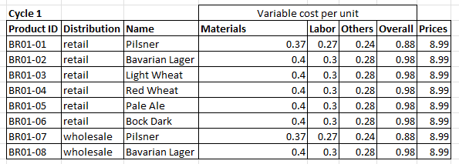

Table 1 : Cycle 1- Prices and Variable Cost per Unit

In cycle 2 (Table 2), we implemented the innovative process improvements to recycle the wastewater and the usage of PET packaging. Recycling of the waste water will directly reduce the material costs of purchasing high quality purified water whereas PET packaging will reduce the cost of beer cups replacement and overall packaging costs for wholesale. There will be additional costs in procurement of the sewage recycling plant, cost of purchasing PET packaging and cost of operating the system. In cycle 2 of simulation, with the innovation plans implemented, the variable costs per unit are changed, which are average $0.375 material costs for retail and $0.365 for wholesale, Labor costs are unchanged i.e. $0.295 for retail and $0.285 for wholesale but other costs are down to $0.253 from $0.273 for retail and $0.24 from $0.26 for wholesale. With this Cycle there is a reduction in the variable costs, increase in expenses but overall the operating parameters of investing in microbrewery are unchanged.

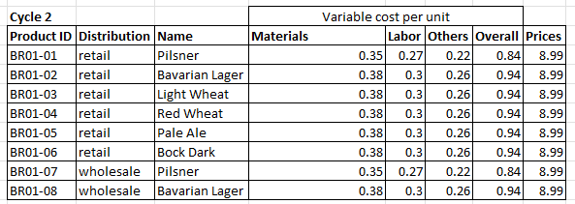

Table 2 : Cycle 1- Prices and Variable Cost per Unit

# 

# Organization and HR Management:

## Human Resources:

When it comes to retaining top talent, it comes down to employee morale and salary expectations. According to Payscale.com, the average salary for a brewmaster with 5-9 years’ experience in the United States is $50,000 (Average Brewmaster Salary) per year. The average business hours would be from 4 p.m. to 12 a.m. and each employee would only work four days a week. The two Brewmasters would be scheduled from 4 p.m. to 12 a.m., Tuesday through Friday, and then the bar manager would be on Thursday through Sunday for the same amount of time and be able to accrue 4 hours of PTO on a biweekly basis. According to salary.com the average salary of a Bar Manager is $39,689 (Bar Manager)(Figure 3). As previously stated in the operating costs, half of the salary amounts for both employees, account for benefits such as health insurance, disability, and life insurance.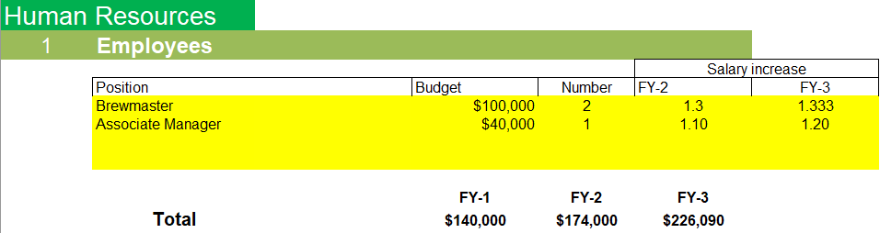

Figure 3

Each employee will be eligible for merit increase at the end of every fiscal year, dependent upon the Taverns financial performance. The merit increase for Brewmasters will be 3% annually and will increase to 3.3% in FY23. The merit increase for the bar/associate manager will be 1% for FY22, and then 2% increase in FY23. if the tavern hits its set financial goals for the year (Figure 4).

Figure 4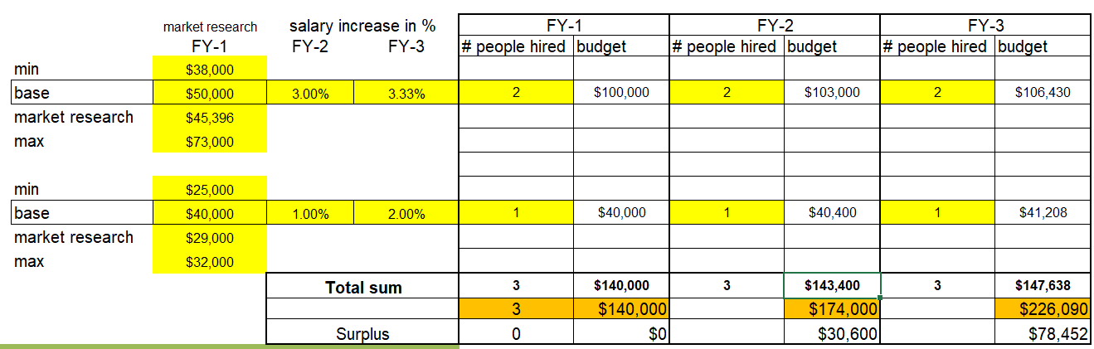

In the future, after the one year period of the proposal, there will be an evaluation in the effectiveness of three workers. In addition to such, there will also be a consideration to expand the business and brewery, and when the time comes, there will also be a change in staffing and increase in demand for them. For such a situation, the price for hiring would also be increased, they should be examined with close comparison and supporting evidence from available financial statements, especially those dealing with the new crafted beer.

Figure 5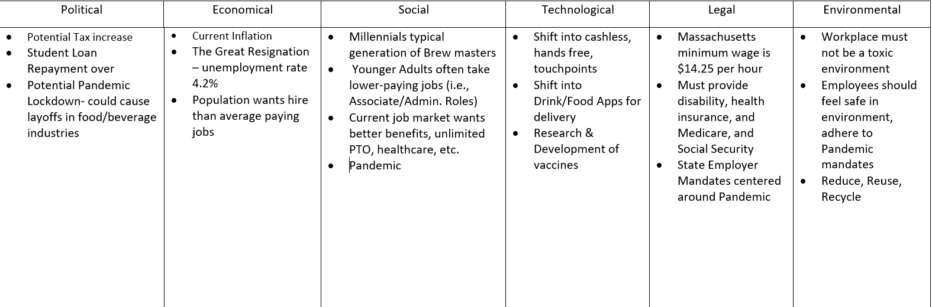

Looking at the analysis in Figure 4, with the year-over-year salary increase, the Tavern will still be in a surplus when it comes to compensation.

# Output evaluation and Performance:

## Output evaluation from each management:

Operation management - This management results in maintaining the consistency or production quantity and the cut-off point of the brews. In this specific management, the number of brews and the cut-off point are the best output indicators, since they closely monitor the production and consumption rate. These are highly valuable, due to their direct effect on waste and costs of the brewery.

Innovation and Technology management - This management results in the focus on technology adaptation into the demand. Should the company not be able to catch up to the trend or demand, they would be lacking behind in satisfying the demand. Since these indicators are hard to keep track of, because there are too many factors that can affect a customer’s selection, specific indicators - while not significant on their own - must be watched carefully. Therefore, this study suggests tracking the amount of new brew consumption, and the rate of new brews introduced every new trend and seasons.

Organizational and HR management - This management results in the focus on the intangible aspect of morale and salary. Should both be maintained at rewarding levels, the three workers would maintain their effectiveness, and their productivity would maintain high.

## Output parameters performance:

Based on the performance from the managements, the parameters for Bud Jaeger to go with and for the investors to watchout for are:

1. Production quantities and cut-off points

In order to properly keep track of the parameters, each brew should have a customized cut-off point and its respective projected quantities demanded. An operation tool that can be used here is the six Sigma rules. The tool can factor in the variety of each time period while still keeping the overall effect of the production. If the production is too low, which results in minimal waste, or even high demand, it would be shown on the tool to be above the sigma lines consistently. Therefore, the production can be adjusted to conserve waste. A rate of continuous production and waste should be consistent, and since the business operates in a “push” system, the backup quantities should be 5% more than projected, and limit itself to be less than 10%.

1. New brews and their rate of consumption

For innovation, the continuous development of new brews shows the adaptation of the brewery. This is especially appealing to the targeted customer base of young adults, since they believe what they drink also expresses themselves to others (*What makes craft beer so popular with millennials?*). Through keeping track of the rate of innovating new brews, the owner can make sure they never fall out of trend and options in regards to their customers. Also, the rate of consumption, and then later discussed on the internet, could also be used not to check the likeliness of the new brew, but the reception of the brew to the customers.

1. Employees morality and payment

Lastly, the morality of the employees can be tracked through their willingness to put in the extra effort at work. This can be noted via the floor manager, or others that the owner can talk to at work. It would show how much the worker values working at the palace. Their extra effort at maintaining the quality of the brew could then be seen through the brewing process, and such should have an effect on their salary. Rather than the old method of employee management of the stick and carrot, there should be a consistency for the employees to fall on, and in this case should be the salary. Their mistakes, and new ideas, should always be received under good reception, and should be properly rewarded based on their effectiveness. A study shows that the high salary not only enables the employees to focus more on their tasks without worrying about making ends meet, but also creates not only a good environment for working, but also helps develop loyalty to the company.

# Summarization and Decision strategy:

In summary, from the management and study we have performed, all the management shows that the conditions are favorable, and there are no visible problems at this stage of the business to present Bud Jaeger in a negative way. Therefore, the investors should proceed with the investment into the company.

Summarizing our management research and application, the best strategy as of right now is to proceed with the acquisition of necessary warehouses and brew tanks. The arrival of the resources and readiness of the workers should be coordinated to be available at the proper schedule. Once situated, the owners should also have a plan to choose brews, with their respective quantities and readiness to invest into public relations to bring awareness to the Bud Jaeger.

When the brewery is up and running, the continuing monitoring of the production and innovation should be of high priority, since they would be the deciding factor of the tavern’s brewing career. The organization and human resources should then be under another review to consider hiring additional workers to create a better work environment, and perform the Toyota Way to layout the tasks, indicators, and open up room for improvement in all areas for the future.

Lastly, after the one year of investment is up, Bud Jaeger can then consider their product deployment to decide whether to go into the option of selling through franchise beer distribution, or should they focus on others before that point.

# 

# **Appendix**:

Figure 1: Contribution of Cycle1 and Cycle2 by Optimization Analysis

Figure 2 - The Cut-off Point of each beer product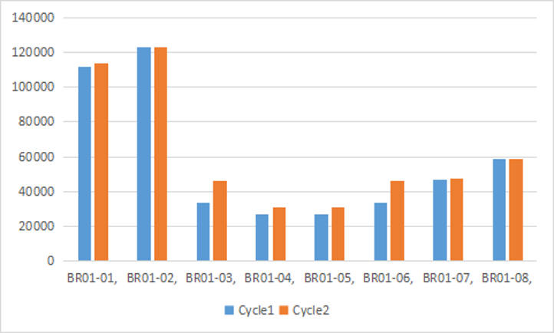

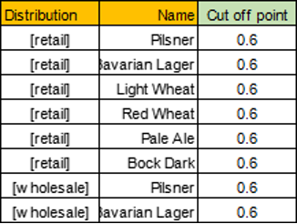

Figure 3



Figure 4



Figure 5



# **Works Cited**

*Average Brewmaster Salary*. (2021). Retrieved from Payscale.com: https://www.payscale.com/research/US/Job=Brewmaster/Salary

*Bar Manager*. (2021). Retrieved from Salary.com: https://www.salary.com/tools/salary-calculator/bar-manager

Boitnott, J. (2018, June 18). *7 reasons you should pay your employees above-average salaries.* Inc.com. Retrieved December 13, 2021, from https://www.inc.com/john-boitnott/7-reasons-you-should-pay-your-employees-above-average-salaries.html.

Carneiro, J. (2018, August 13). *What makes craft beer so popular with millennials?* LinkedIn. Retrieved December 13, 2021, from https://www.linkedin.com/pulse/what-makes-craft-beer-so-popular-millennials-joana-carneiro.

*The Oktoberfest statistics*. Oktoberfest. (n.d.). Retrieved December 13, 2021, from https://www.oktoberfest.net/oktoberfest-statistics/.

Settembre, J. (2019, May 9). *Millennials spend more on craft beer than they do on their cell phone and utilities*. MarketWatch. Retrieved December 13, 2021, from https://www.marketwatch.com/story/more-proof-that-millennials-are-beer-snobs-2019-05-02.

*What makes craft beer so popular with millennials?: DSM Food Specialties*. @dfs. (2021, November 8). Retrieved December 13, 2021, from https://www.dsm.com/food-specialties/en_US/insights/beverage/craft-beer-millennials-consumer-insights.html.